**Proposal Phase Report**

**Team ID: 4A17**

**Category: Application Development Project**

**Title: Appliance Store Management system**

**List of Team Members:**

|  |  |  |
| --- | --- | --- |
| **Roll number** | **USN** | **Name** |
| 43 | 01FE18BCS043 | Anusha Raikar |
| 44 | 01FE18BCS044 | Apoorva Jinde |
| 45 | 01FE18BCS045 | Archana Badagi |
| 54 | 01FE18BCS054 | Ashwini Banagar |

**Team Leader:** Apoorva Jinde

**Responsibilities:**

**Anusha Raikar:**

Collection of all data from the clients required for the project.

ER to relational Mapping. Data Dictionary.

**Apoorva Jinde:**

Developing ER model for the management selected

ER to relational Mapping. Object Model

**Archana Badagi:**

Developing ER model for the management selected.

Collection of all data from the clients required for the project.

**Ashwini Banagar:**

Developing ER model for the management selected. Documentation

**Problem Description:**

We came across a problem that the shop has a huge collection of customer and supplier data which they were managing in ledgers and Excel sheets. They did not have any computerized system for now and the bill they generate was by entering the data in the cells of excel sheet. A lot of time is consumed during the process of business activity. And the customers apply for AMC should be given services which they used to mark on calendar manually hence they would mess up having the wrong number of count of the services provided to customer. So we came up with the idea of providing them a computerized system to improve the efficiency and performance of their daily business activity.

**Requirements:**

1) To maintain details of all the customers and employees.

2) Bill Generation

3) Notification to provide service to customer who have taken up AMC(Annual Maintenance

Contract)

**Design Questions to be answered**

**Question 1:** From the problem description, identify the entities that need to be represented in the database, the attributes of each entity, the relationships between the entities, and the cardinality ratios of each relationship.

**Entities and Attributes**

1. **Shop**:
2. GST_NO
3. ShopName
4. Address
5. Location
6. **Employee:**
7. EmpId
8. E_Fname
9. E_Lname
10. Salary
11. Qualification
12. PhoneNo
13. AadharNo
14. JoinDate
15. Address
16. **Supplier:**
17. GST_no
18. DateOfSale
19. SName
20. PaidAmt
21. TotalAmt
22. PhoneNo
23. **Products:**
24. ProductId
25. Brand
26. ProductName
27. GSTAmt
28. TotalPrice
29. Features
30. **Bill:**
31. Bill_ID
32. BDate
33. PaidAmt
34. TotalAmt
35. PaymentMode
36. **Customer:**
37. CustId
38. C_FName
39. C_LName
40. PhoneNo
41. CustAddress
42. **AMC:**
43. RecNo
44. AMCQuantity
45. MaintenanceYears
46. TotalNoServices
47. NoOfServicesDone
48. LastService

Any number of employees can work for a single shop. Therefore n:1 will be the cardinality ratio. Total participation by both employee and shop as every employee’s detail added to the table has to belong to the shop and the shop has to be there for the person to be as employee.

Each shop owns many products .Therefore there is 1:n cardinality ratio. Total participation by both shop and products as there cannot be products which are not under the shop and there cannot the shop without no products.

Any number of suppliers supply any number of product, so there is n:m cardinality ratio. Total participation is by both supplier and products as products are brought by supplier and there can be no suppliers who provide no product thus we require supplier and product.

Many products can be brought under one bill. And one product can be brought by many bills. Therefore the cardinality is n:m . There is total participation of product as there cannot be bill without bill but there can be existence of product without bill hence bill is partial dependent.

Each customer can come multiple times to buy the shop and has many bills. Therefore there is 1:n cardinality ratio between customer and bill ,and total participation from both customer and bill, because if bill is generated then there must be a customer and if customer details are stored then there must be a bill generated.

As one AMC_No is specified for a particular number of products of the same kind if applied for one bill. Hence the cardinality ration b/w product and AMC is 1:1 .There is total participation of the product as there can be no AMC without product but the AMC’s participation is optional as only the chosen products have AMC not mandatory all the products we purchase.

**Question 2:** Draw an Entity-Relationship Diagram illustrating the information you have identified in Question 1.

**1ST ER Diagram:**

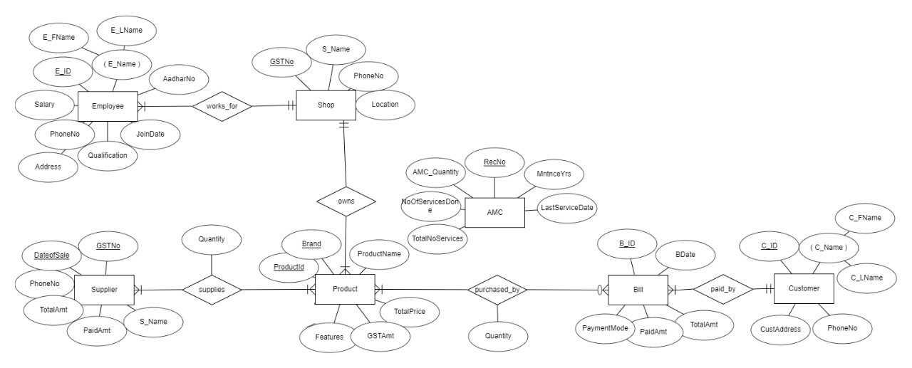

**Question 3:** Draw **alternate** Entity-Relationship Diagram illustrating the information you have identified in Question 1 that you think are most likely to occur.

**2nd ER Diagram:**

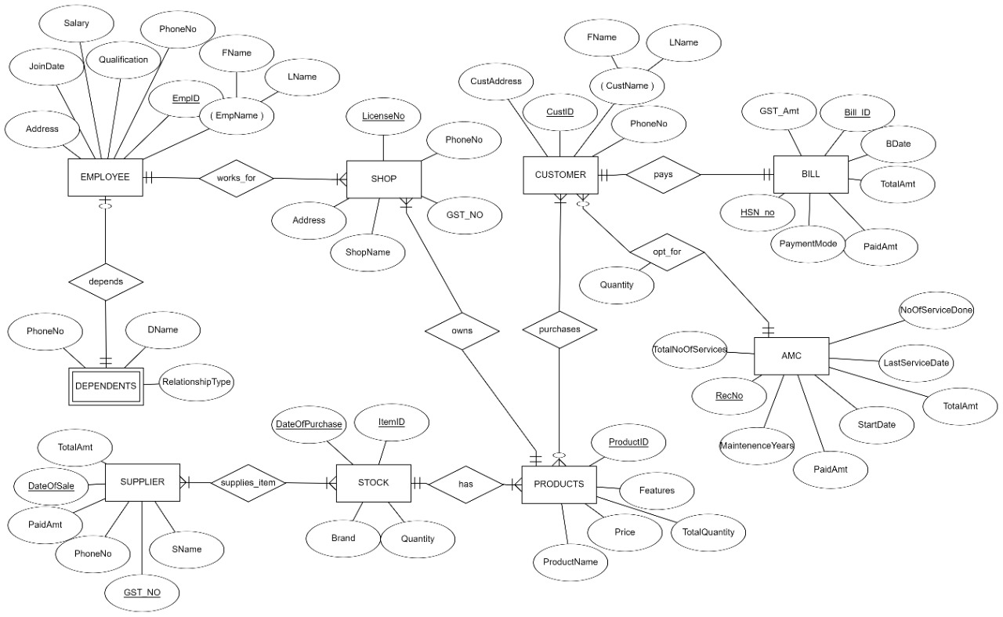

**3rd ER Diagram:**

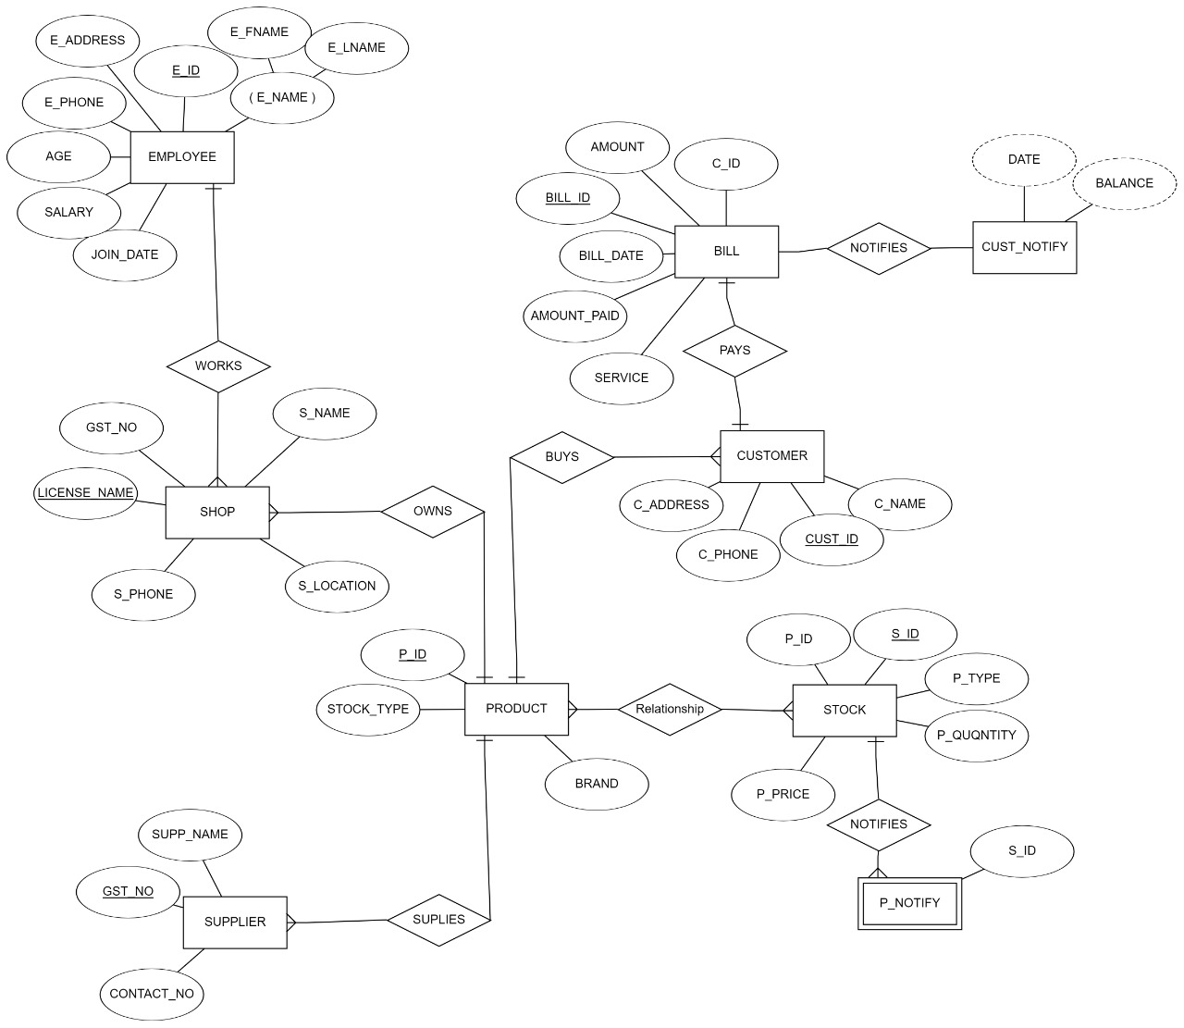

**Question 4:** Choose the **optimal** Entity-Relationship Diagram from the designs provided above and justify why you think this is an optimal solution for your identified problem specification.

We have opted for the **1st ER Diagram** because the requirements as per the entities where in this model.

As in the **2nd ER Diagram** we observe that the products should be connected to bill and then the customer to the bill but we had connected the products and customer and then customer to bill. Hence we rejected this model

In the **3rd ER Diagram** we can see we had created extra entities like notify and stock which are not required and their requirement can be directly fulfilled using appropriate query hence we rejected this model.

Therefore the model which we have selected as **optimal one** satisfies all the **requirements** with **minimum number of tables.**



**[Optional] Question 5:** Draw an Object Model illustrating the information you have identified in Question 2.

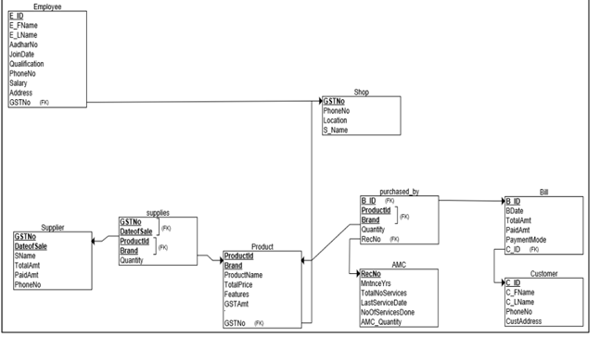

**Question 6:** Draw an ER to Relation Mapping illustrating the information you have identified in Question 4.

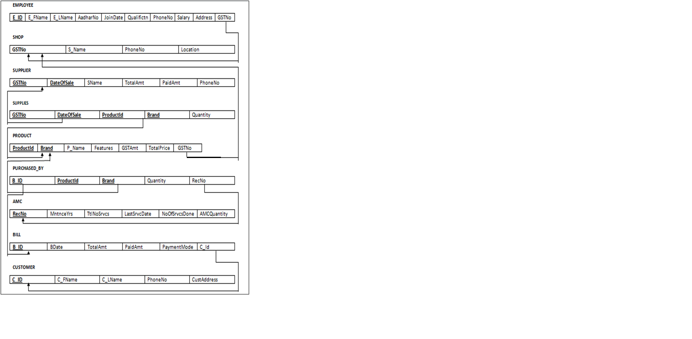

**Question 6:** Draw a Data Dictionary illustrating the information you have identified in Question 6.

|  |  |  |  |  |  |
| --- | --- | --- | --- | --- | --- |
| **Object (Entity)** | **Name (Attribute)** | **Type**  **(Data type)** | **Description** | **Primary Key** | **Foreign Key** |
| Shop | GST_NO | String | Unique identification number for the Shop. | Yes | No |
|  | S_Name | String | Name of the Shop | No | No |
|  | Location | String | Location/Address of the Shop | No | No |
|  | PhoneNo | Integer | Phone number of the Shop | No | No |
| Employee | EmpId | String | Unique identification for each employee | Yes | No |
|  | FName | String | First name of the employee | No | No |
|  | LName | String | Last name of the employee | No | No |
|  | Salary | Integer | Salary of the employee | No | No |
|  | Qualification | String | Qualification of the employee | No | No |
|  | PhoneNo | Integer | Phone number of the employee | No | No |
|  | Address | String | Address of the employee | No | No |
|  | JoinDate | Date | Date on which Employee joined | No | No |
|  | AadharNo | Integer | Unique Aadhar number of the Employee | No | No |
|  | GSTNo | String | GSTnumber of the shop | No | Yes |
| Customer | CustId | String | Unique identification number for the customer. | Yes | No |
|  | C_FName | String | First name of the customer | No | No |
|  | C_LNname | String | Last name of the customer | No | No |
|  | PhoneNo | Integer | Phone number of the customer | No | No |
|  | CustAddress | String | Address of the customer | No | No |
| Product | ProductId | String | Unique id for the product | Yes | No |
|  | Brand | String | Name of the company brand the product belong to | Yes | No |
|  | ProductName | String | Name of the product | No | No |
|  | GSTAmt | Integer | It is the GST amount the product of this brand holds | No | No |
|  | TotalPrice | Integer | Amount Price of the product plus the GST amount which is the total price of that particular product | No | No |
|  | Features | String | Features of the product | No | No |
|  | GSTNo | String | GST number of the shop | No | Yes |
| Bill | Bill_ID | String | Unique id for bill | Yes | No |
|  | BDate | Date | Date of billing | No | No |
|  | TotalAmt | Integer | Total amount generated(including gst) | No | No |
|  | PaidAmt | Integer | Total amount paid | No | No |
|  | PaymentMode | String | Mode of transaction of money | No | No |
|  | CustID | Integer | Id of customer who purchased products | No | Yes |
| Supplier | Gst_no | String | It is the unique number of the supplier | Yes | No |
|  | DateOfSale | Date | Date of sale of products | Yes | No |
|  | SName | String | Name of the product supplying company | No | No |
|  | TotalAmt | Integer | Total amount generated | No | No |
|  | PaidAmt | Integer | Total amount paid to supplier | No | No |
|  | PhoneNo | Integer | Contact number of the supplier | No | No |
| AMC | RecNo | String | Unique id given to each record of amc service | Yes | No |
|  | TotalServices | Integer | Total number of services to be given to customers | No | No |
|  | NoOfServicesDone | Integer | Total number of services already given to customers | No | No |
|  | LastServiceDate | Date | Last service given to customer | No | No |
|  | AMCQuantity | Integer | Quantity of products on which amc is available | No | No |
|  | MaintainenceYears | Integer | Total number of years of service | No | No |
| Supplies | GSTNo | String | Unique identification number for every trader. | Yes | Yes |
|  | DateOfSales | Date | Date on which the goods were bought by the supplier | Yes | Yes |
|  | ProductId | String | Unique id for the product | Yes | Yes |
|  | Brand | String | Name of the company brand the product belong to | Yes | Yes |
|  | Quantity | Integer | Number of particular brand product the supplier brings on that particular date | No | No |
| Purchased_by | B_Id | String | Unique id for bill | Yes | Yes |
|  | ProductId | String | Unique id for the product | Yes | Yes |
|  | Brand | String | Name of the company brand the product belong to | Yes | Yes |
|  | Quantity | Interger | Number of particular brand product the customer buys | No | No |
|  | RecNo | String | Unique id given to each record of amc service | No | Yes |

**References:**

Tool used to draw the ER diagram and object diagram:<https://erdplus.com>

**Submission Date: 13 feb 2020**